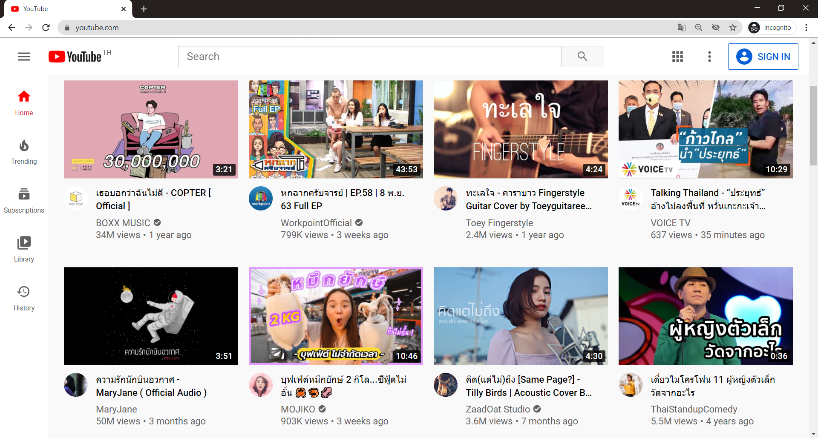

19:48:df:a9:7f:6d

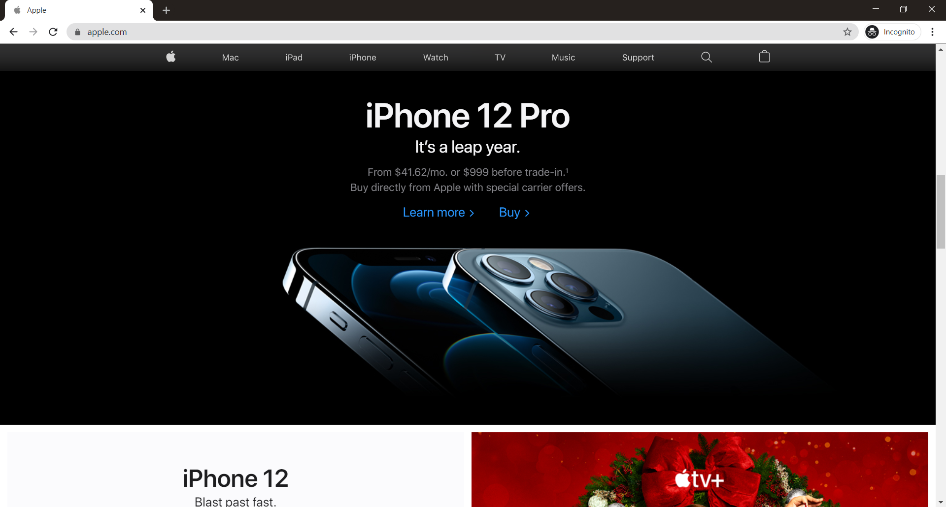

f2:cf:85:cf:98:a9

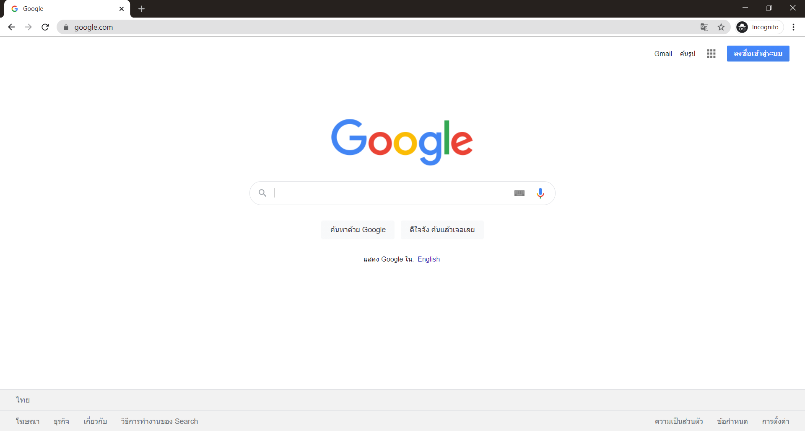

7e:22:11:9b:01:a4

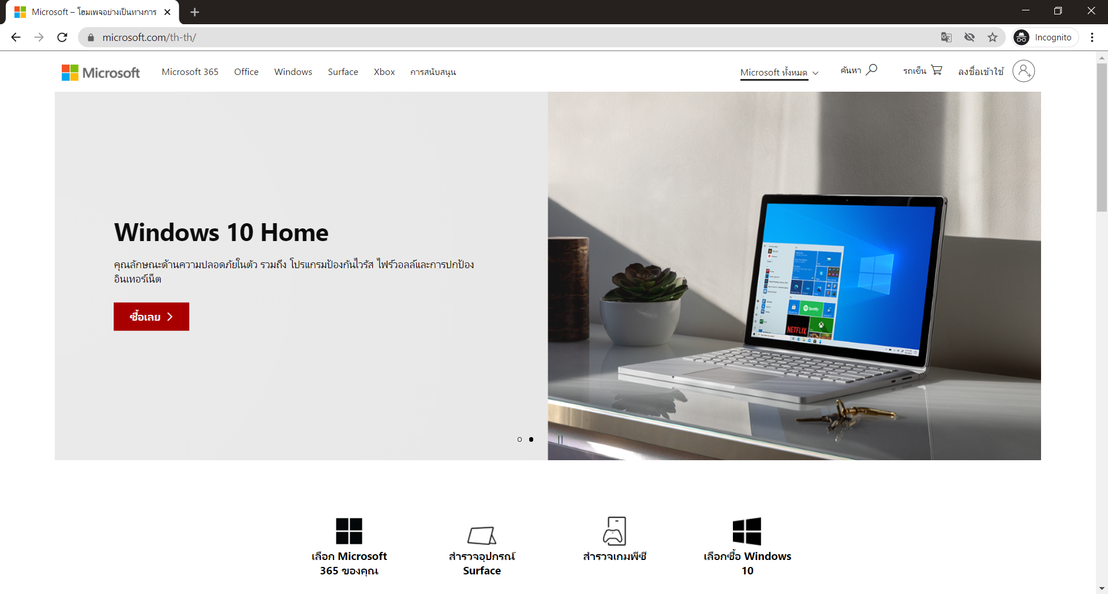

b5:90:5f:f3:f1:96



f1:04:eb:99:be:14

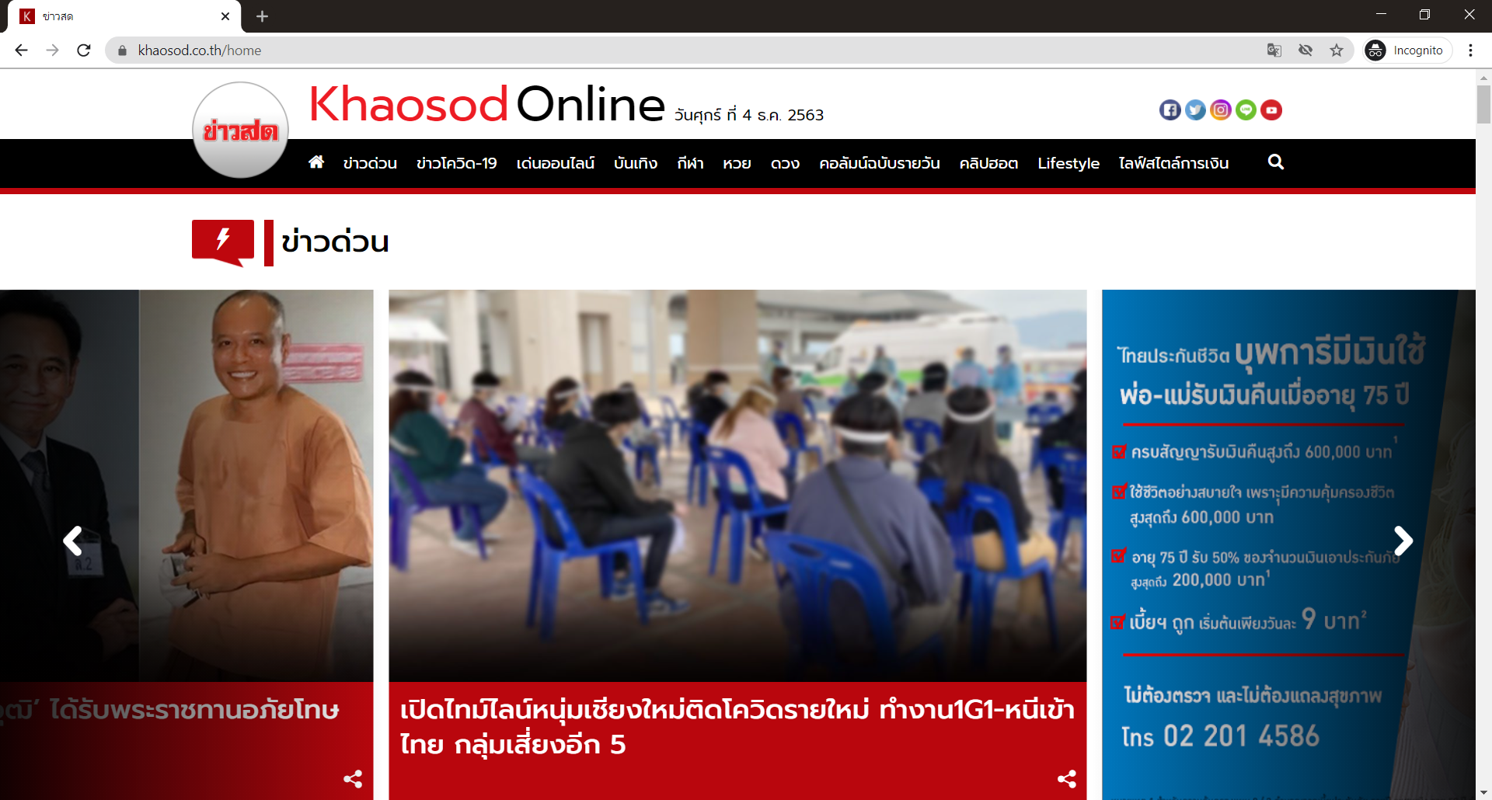

36:f2:72:71:8d:b4



bd:e1:81:56:0b:d8



ba:6f:43:34:de:dc



cc:8c:76:69:cd:10



90:ea:83:e0:45:f1



88:5e:f5:b2:83:de

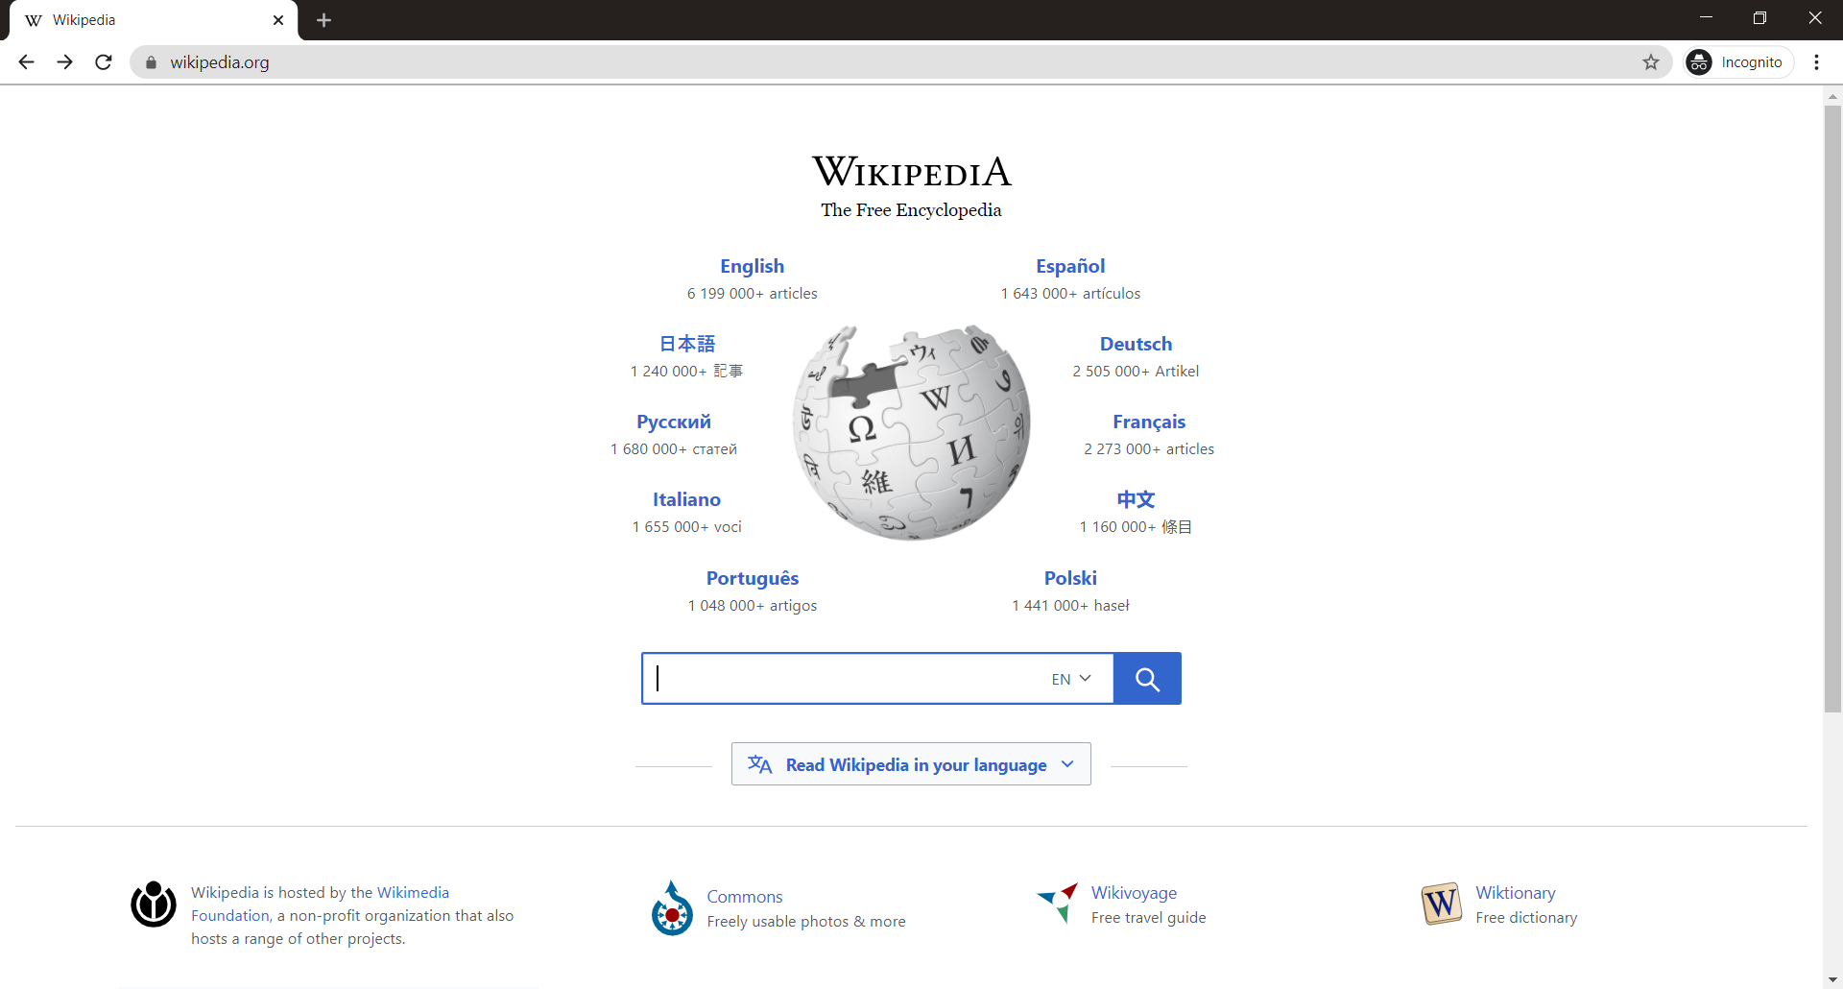

fb:2a:b8:45:ca:7c



35:4f:8b:b8:93:d1

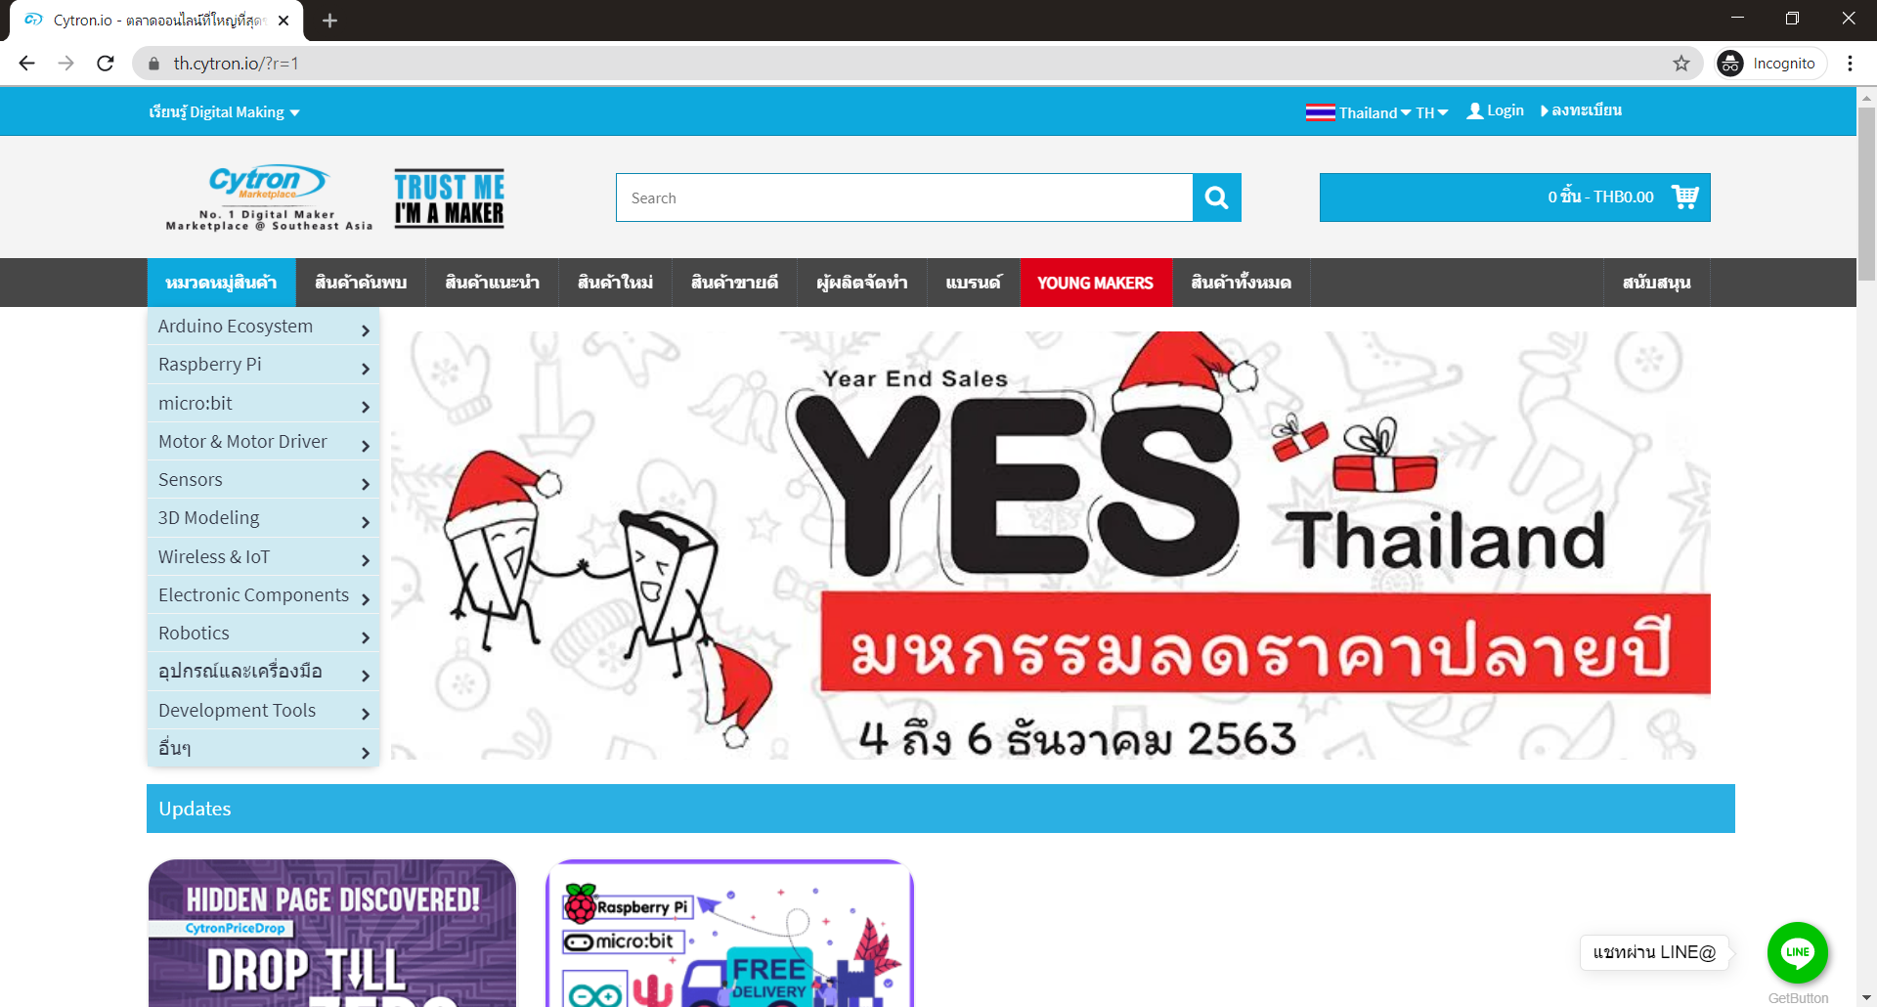ce:07:9e:e6:74:19

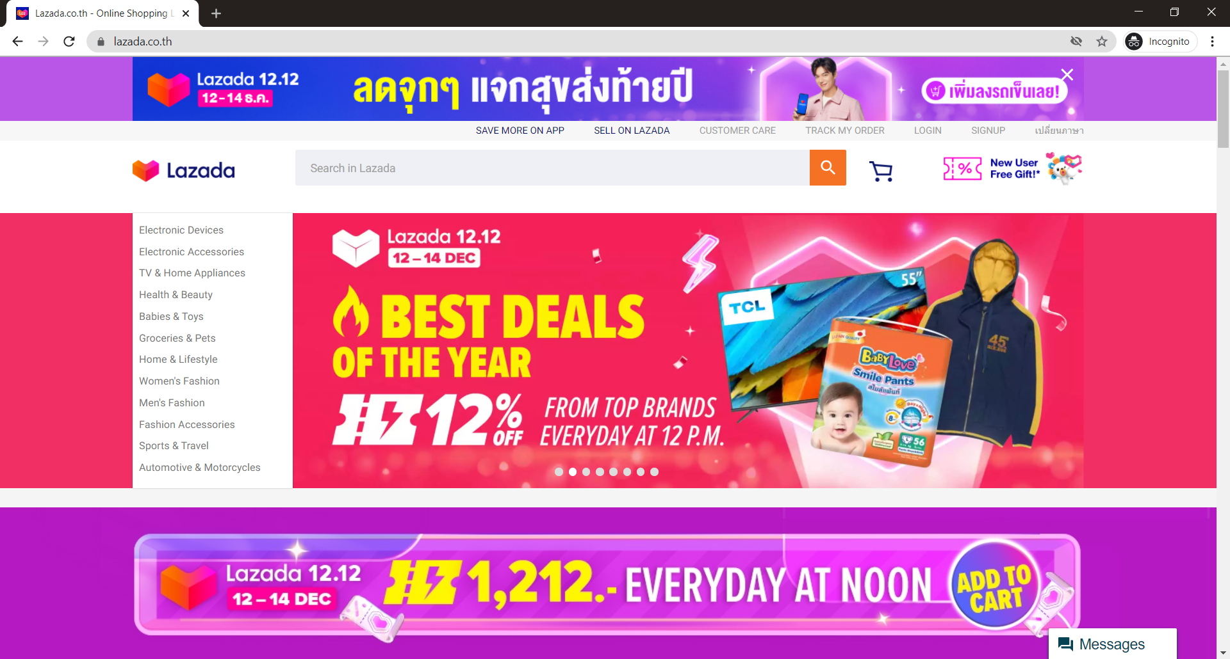

ac:ae:0f:4a:cd:0e

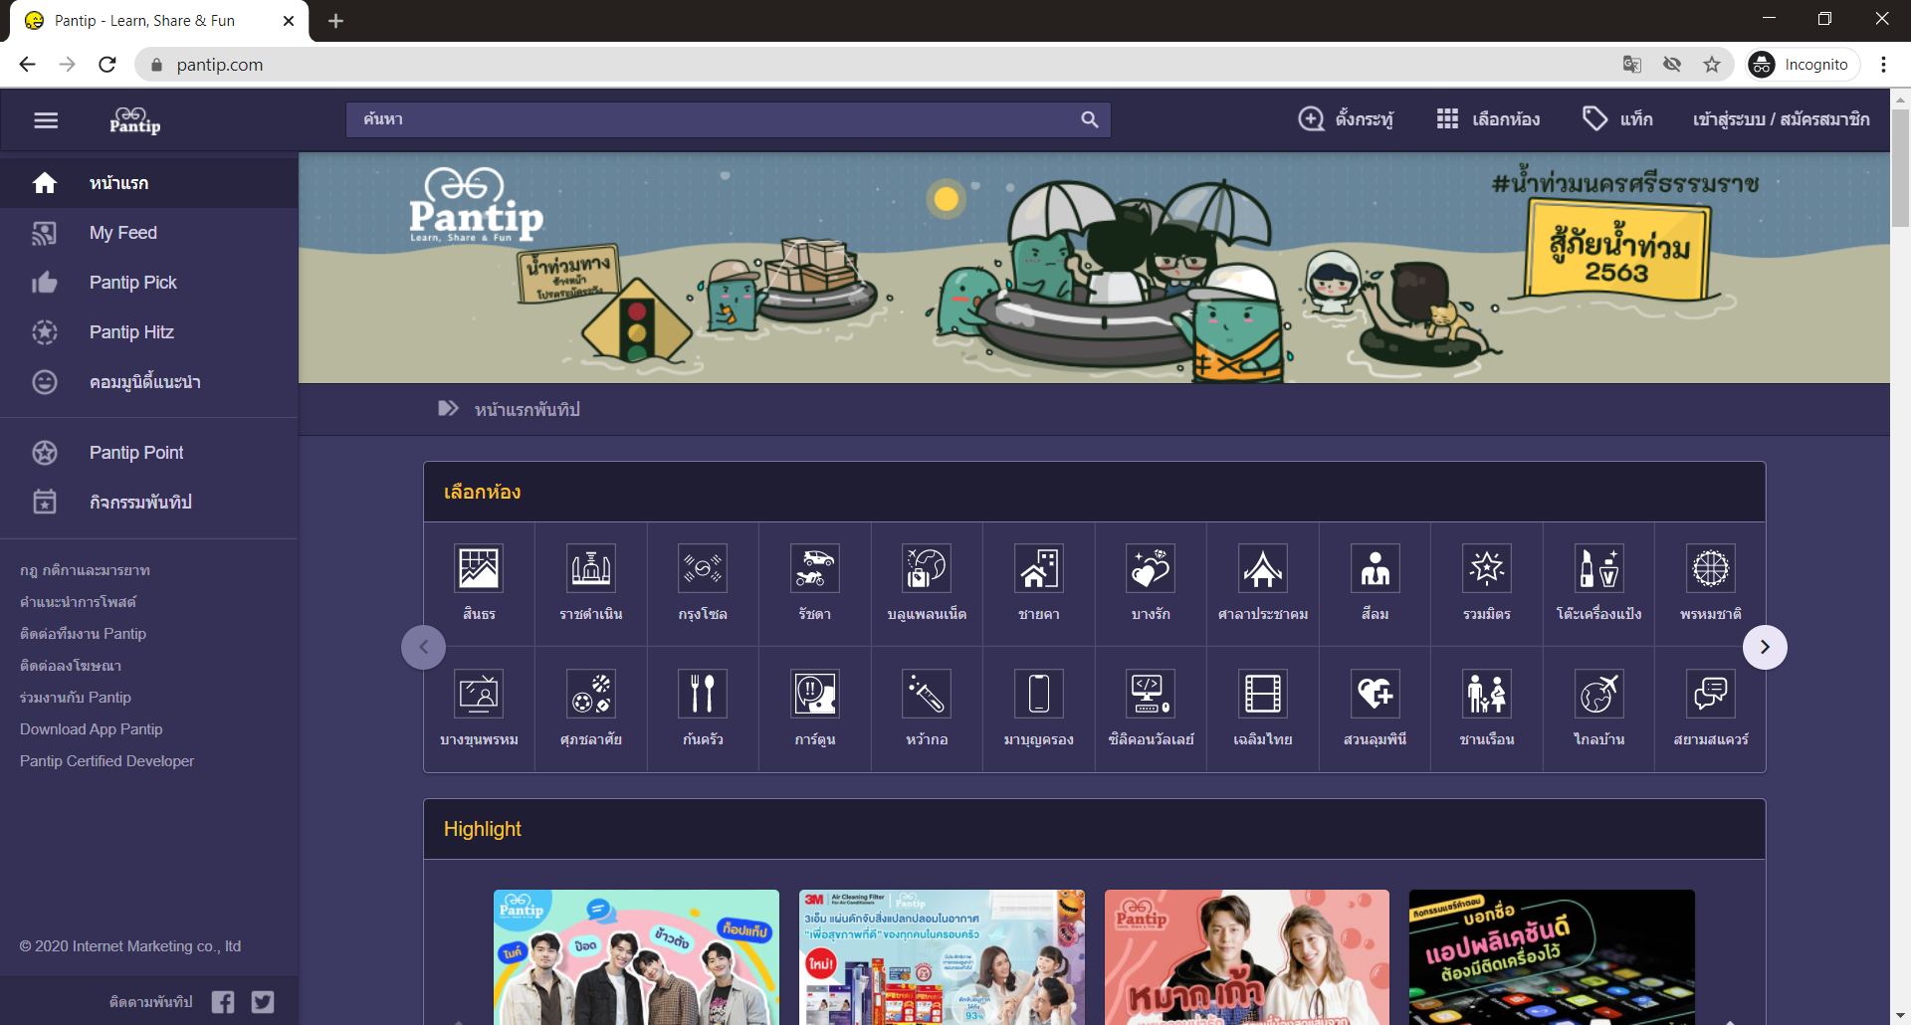

0a:de:7f:de:f0:77



dd:84:cd:c0:44:03



2b:99:d2:2c:0d:b0



f4:c6:a7:8b:2f:10



f2:44:1e:bd:9d:fb



79:3c:9f:33:d9:19



20:28:ae:09:27:ae



a0:20:c4:26:83:94

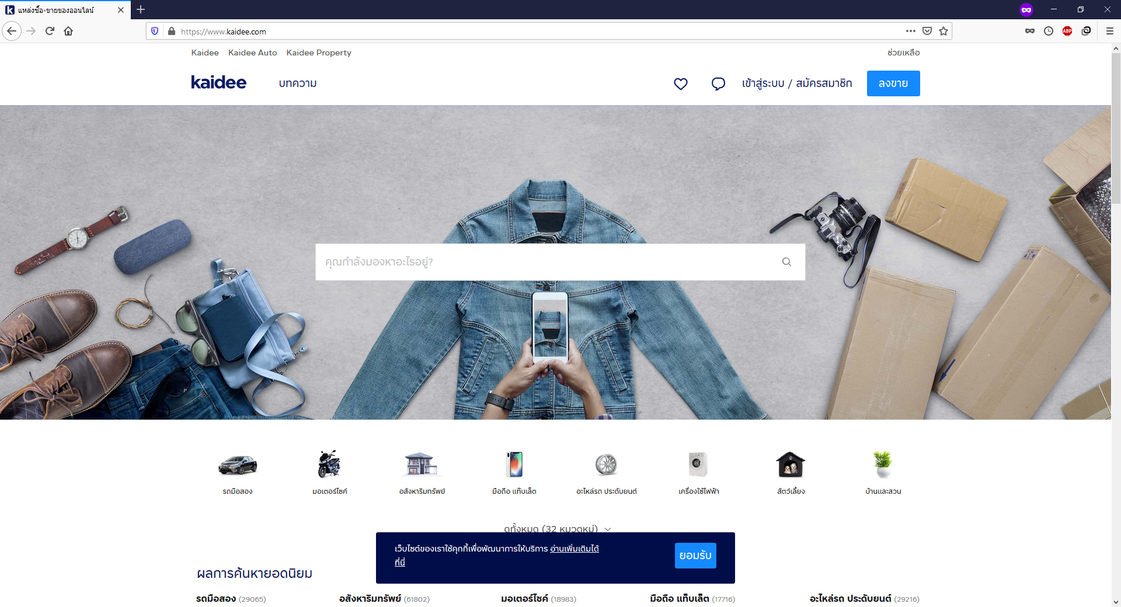

e9:09:fe:72:a3:f8

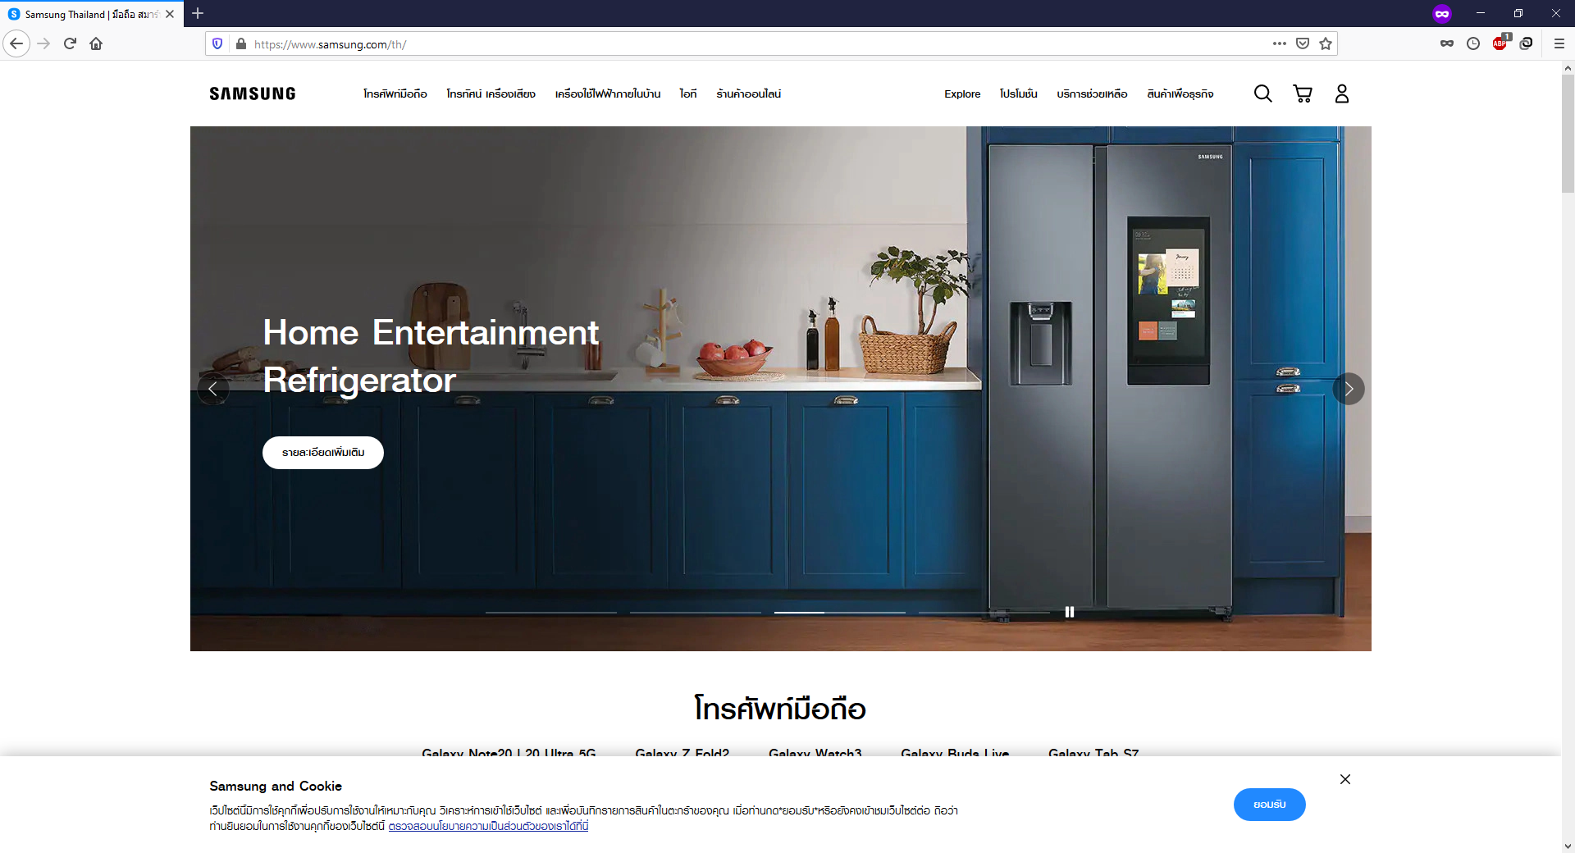

15:ba:06:37:03:f0

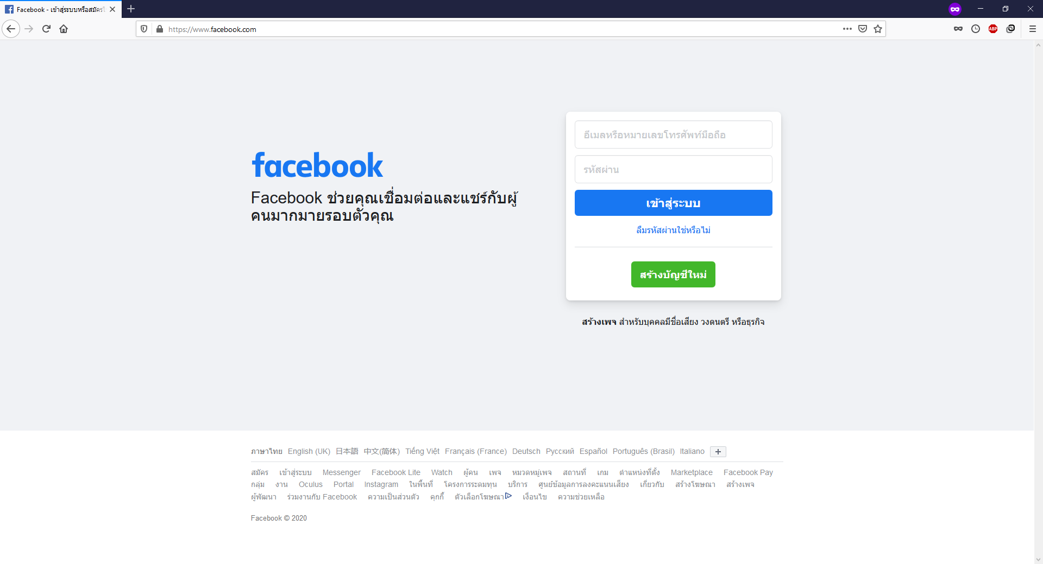

37:56:a4:b2:8f:1c

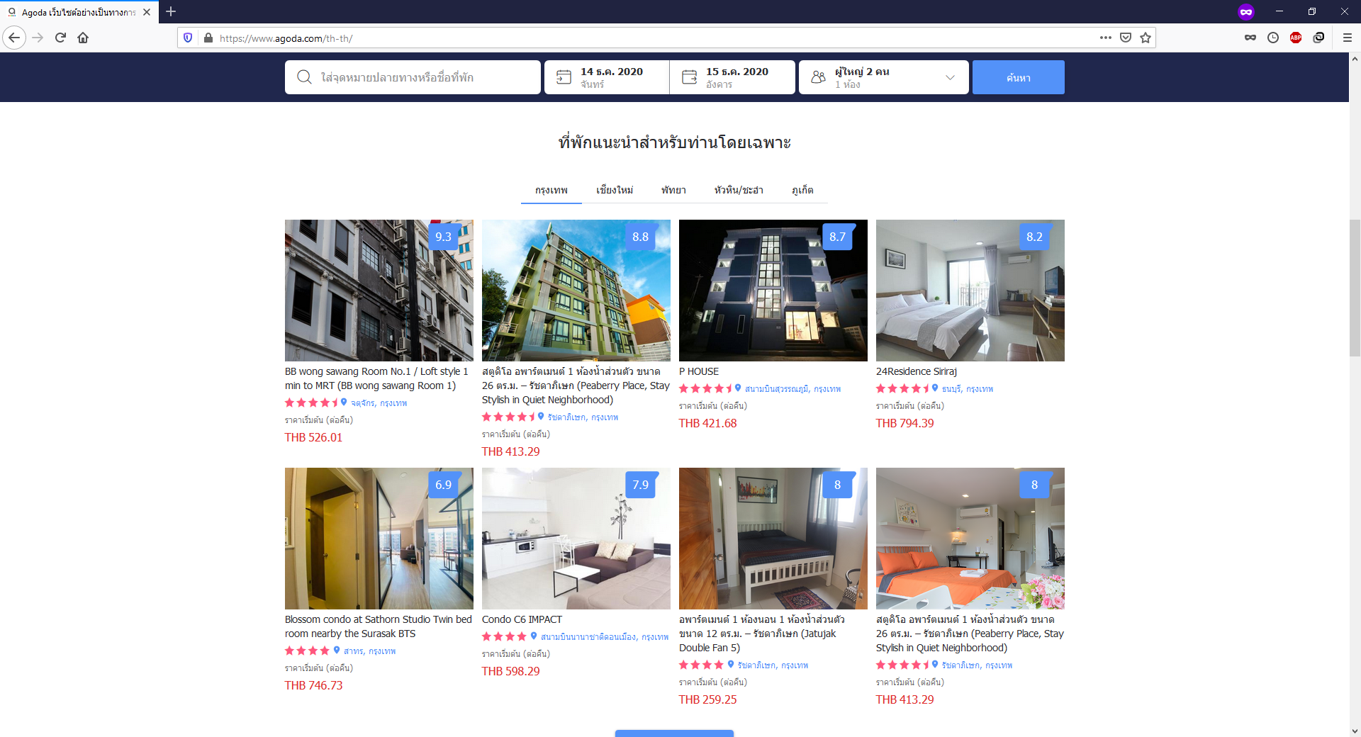

54:cc:dd:1e:2a:aa

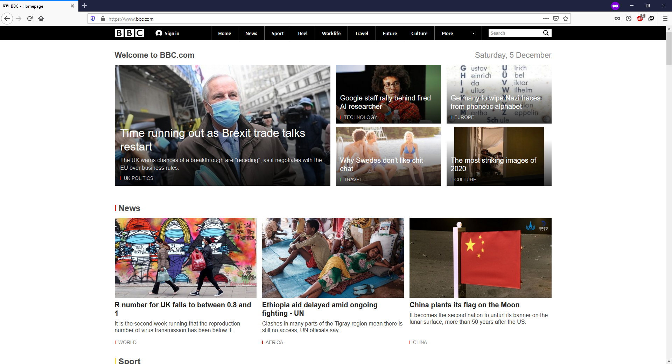

24:92:ab:04:96:7d



34:7d:a8:72:0d:55



c1:b0:b3:a9:88:67

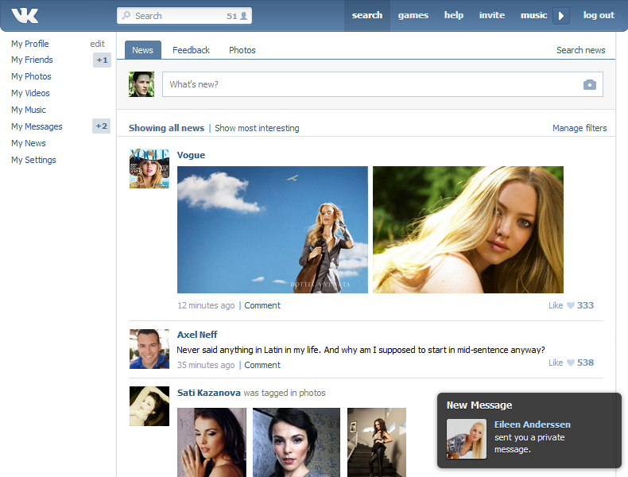

75:7e:bc:08:e8:21



25:b5:7a:86:b1:75

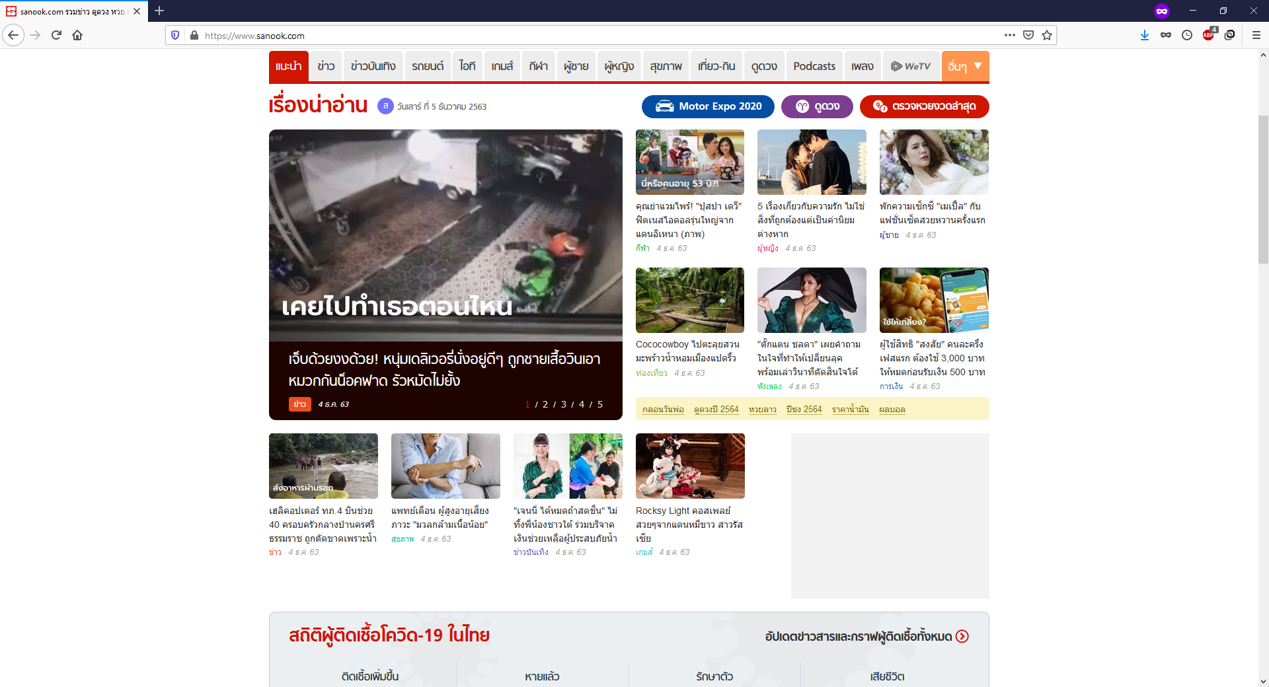

c7:01:00:2b:6d:0d

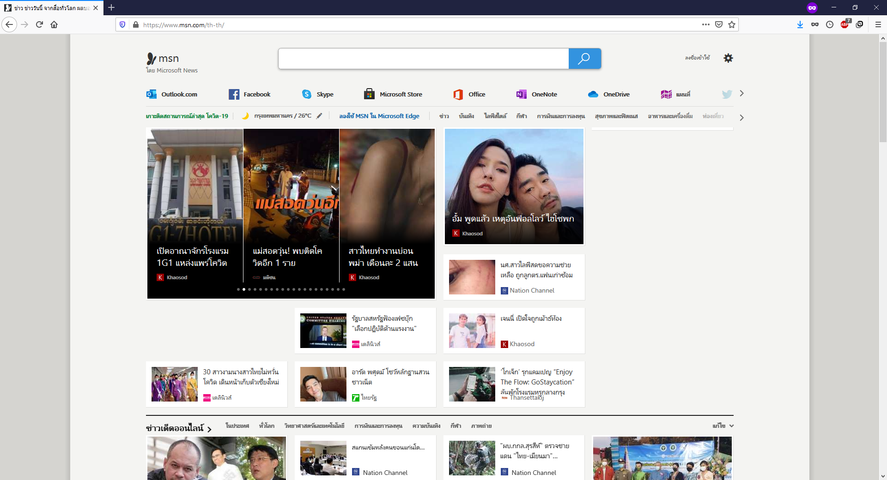

e0:3d:98:1e:c6:1e

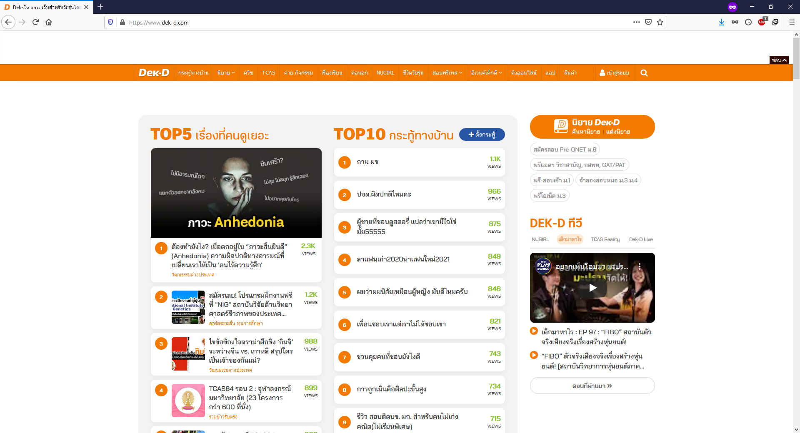

45:ec:02:82:09:22

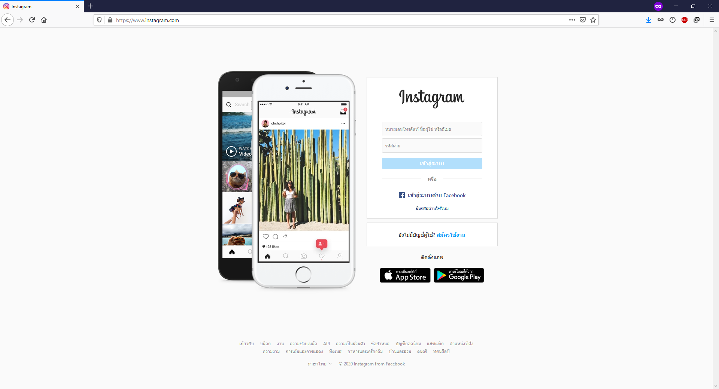

eb:9a:76:a2:3b:93



93:87:1b:53:f2:3d

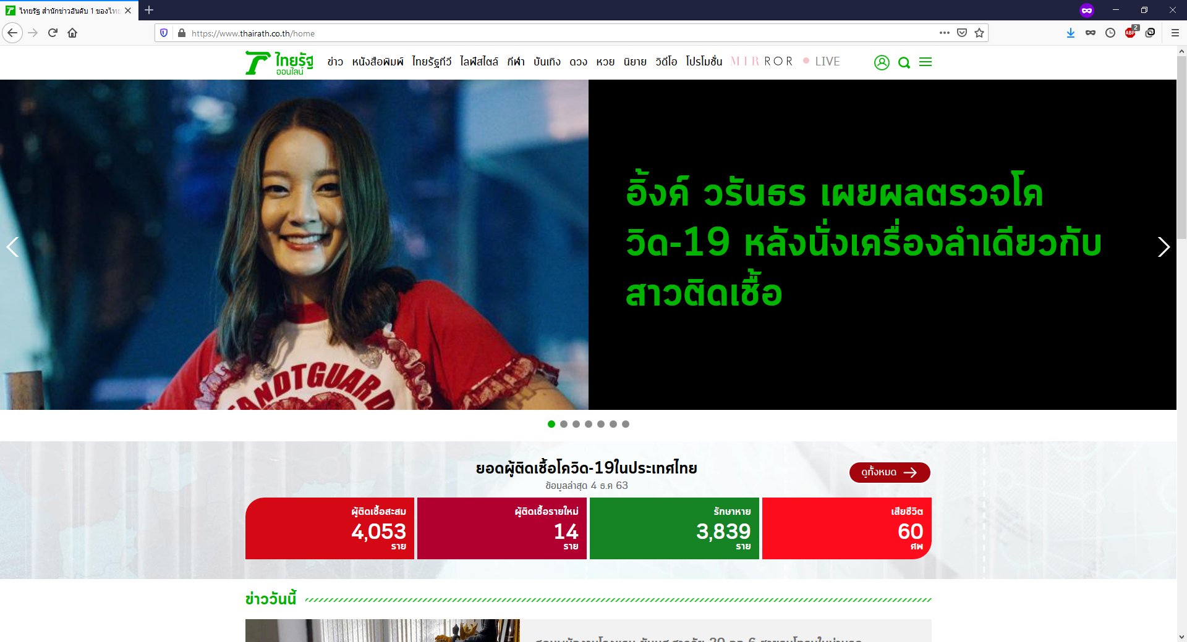

df:e6:0c:96:a7:51



2e:e5:99:57:ee:86



c5:8d:1d:66:d3:e2

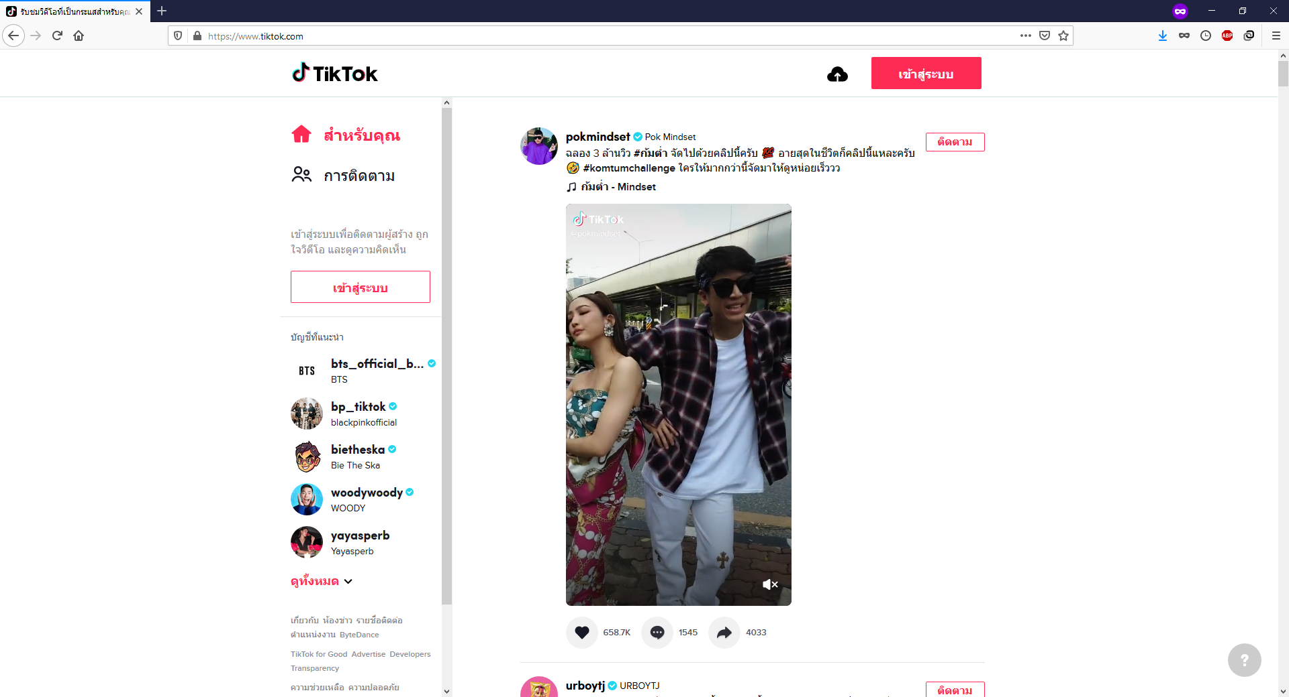

76:19:6c:59:29:62



d6:e7:69:0c:5b:3e



c8:2b:8d:a4:f3:40



b5:09:62:ef:3f:25



bb:8b:62:82:02:35



50:93:f8:aa:00:6c

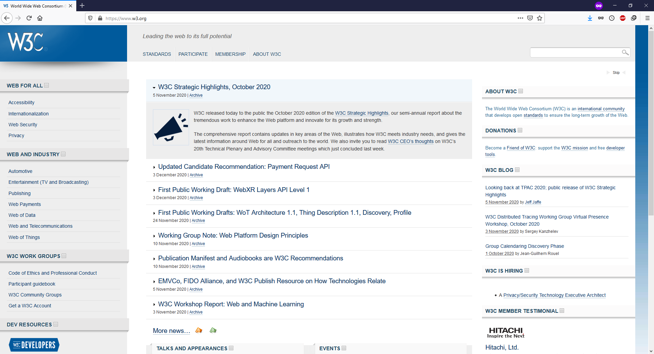

6e:e7:1d:4c:3b:47

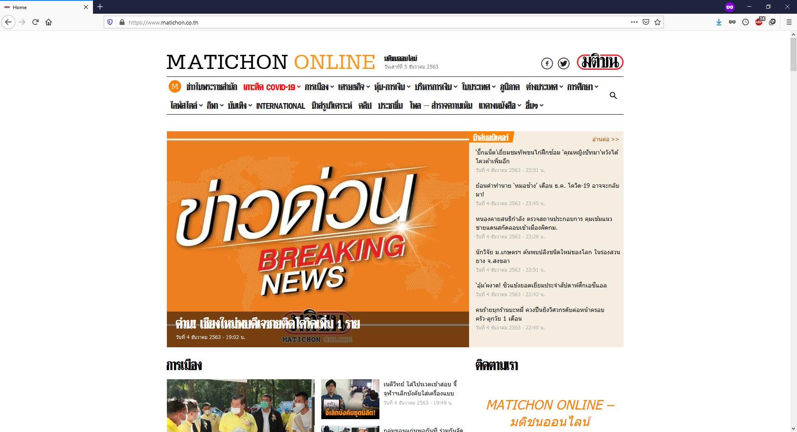

5c:d4:82:27:fd:6f

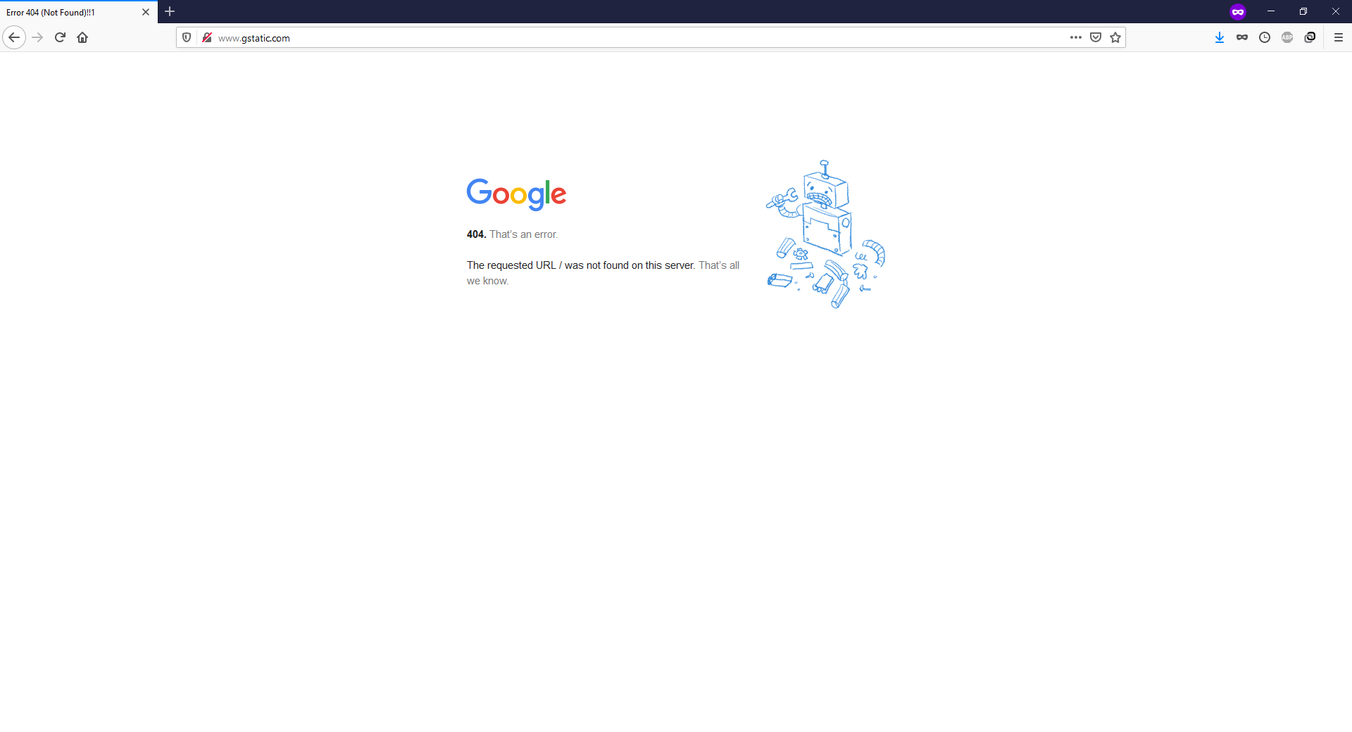

87:0c:98:ce:2e:52



18:f2:10:67:43:8c

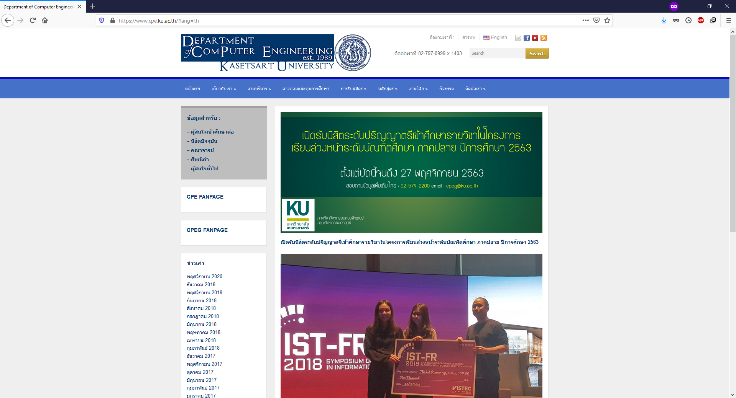

8b:aa:aa:55:8b:ae